PIDOXA LEGAL · PERSONAL INJURY · JOURNEY RATIONALE AND CLIENT-JOURNEY FRICTION MAP
Why the journey is built this way
The companion to the interactive Case Value Diagnostic: the planned end, the journey map, the 1–5 scale and segmentation, where every psychological trigger sits, how the symptoms of a brand gap are argued, the client journey and its friction points, how the SCALE engine is introduced, how the model and the score are computed, compliance, data flow, and the pre-launch checklist.
Pidoxa Marketing · Legal practice group · Centennial, Colorado · October 2026 · Live at pidoxa-legal.hosting.pinbn.net

1. The planned end
Every path through the journey ends in the same place: a booked case value strategy session, with a readout the attorney has already read attached to the lead, routed to the right person for the size of the firm. Everything before that exists to make the booking feel like the obvious next step rather than a sales ask. The journey is a business-to-business tool — Pidoxa talking to the attorney — but its subject is the injured person's and the family's journey, because that is the thing the attorney is losing.
- Before the ask. Six-tile front door framed as the symptom, four segmentation questions, the scale defined and the mix distributed, seventeen diagnostics with two lessons inside them, a visible "building your readout" moment, and a full readout. No contact field appears until the readout has been read.
- The ask. TCPA-compliant capture with the readout summary attached (including the mix and the model), an optional "also send to the partner who decides with me" field, then a booking step. The one-firm-per-metro conflict check is stated here.
- After. Peak-end screen that names the reviewer, repeats the requested time, and sets three expectations: human review within one business day, the call runs on their intake log and numbers, and they leave with a written scope rather than a deck. Established and regional firms are routed by name to the CRO.
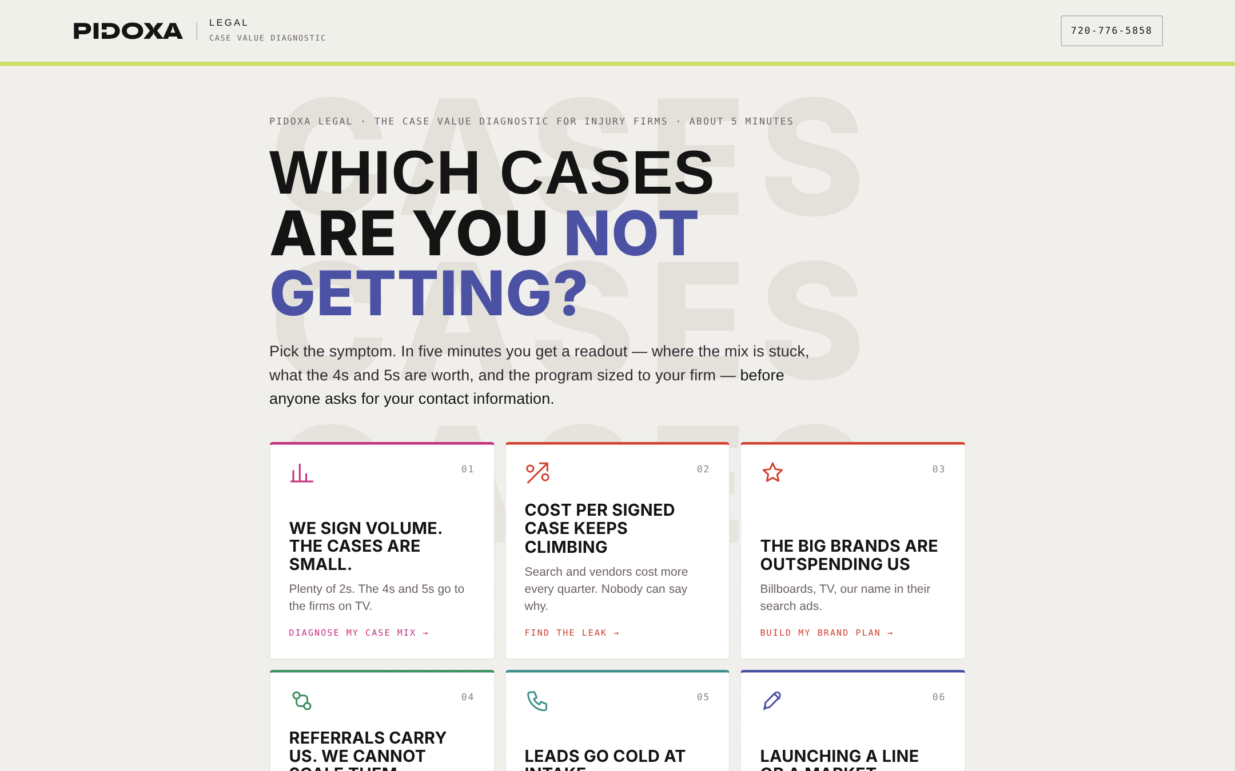
The front door. The attorney names the symptom before anything is asked.

2. The journey map
Hash-routed, one question per screen, every answer stored in the state object. The order is deliberate: identity questions first, the scale before any diagnostic so every later question is asked in tier language, diagnostics in the order a strategist would ask them, the two lessons placed right after the question that exposes the gap each addresses, and the two commitment questions last, when the attorney is most invested.
Step | What happens | Trigger
Front door | Which cases are you not getting? Six symptom tiles: volume but small cases · cost per signed case climbing · the big brands outspend us · referrals carry us · leads go cold at intake · launching a line or market. The symptom reorders the recommended services and the readout headline. | Self-selection, autonomy, reciprocity set up
Segment 1–4 | Attorneys · Footprint · Case types · Monthly spend. Firm size (boutique / growing / established / regional), footprint, the case types actually signed (trucking and wrongful death tagged "high value"), and spend. Spend and a multi-state footprint can move the segment up. | Personalization, similarity, authority (98% reach)
The scale | Tiers 1–5 defined with recovery range, planning fee and time to resolve, then five sliders that must add to 100. The mix drives the Create pillar, the findings, the model and the HubSpot record. | Endowment, anchoring on fee values
The one you lost | Think of the last tier-4 or tier-5 case in your metro that you did not get. Who did? TV firm / referred firm / whoever answered first / us / unknown. | Loss aversion, availability heuristic made explicit
Lift diagnostics | Where did last quarter's signed cases come from · Can you attribute signed cases by tier. Attribution carries the last-click insight note rewritten for memory media. | Honesty framing, insight
Method | When your marketing people say "funnel"… → Lesson 1: a click funnel catches the 2s, a journey earns the 5s. Three facts: $442 CPL, 5–15% sign rate, $2.9K–$8.8K per signed case; the foot does the tier-2 vs tier-4 arithmetic. | Contrast, authority, loss aversion
Earned · brand | If a family searched your name tonight, what would they find? → Lesson 2: paid buys the introduction, earned wins the hospital bed. Lists the symptoms of a brand gap, then what Create and Lift do; names the $1.2B legal TV market. | Social proof inverted, authority, contrast (out-remember, not out-spend)
Acquire diagnostics | The Saturday-night call · Tier triage in ninety seconds · Who is your marketing talking to (the parallel buy flow) · What happens to the case you cannot handle. | Vivid scenario, insight (cheapest fix), trust
Signal | Which channels are live · How is paid performing in signed cases. CTV and programmatic tagged "journey channel"; lead vendors as their own option; "we paused it and the phone got quieter" is a strong buying signal. | Loss aversion
Create · Lift | One firm across site, ads, intake and settlement letters · How often the attorney appears on video · When the site was last rebuilt (with the 51% live-chat fact). | Fluency, proof
Commitment | Who else decides · When. Deciders drives the share-with field; timeline carries the honest urgency note: one firm per metro, Q1 2027. | Commitment and consistency, consensus, scarcity, urgency
Build | Building your case value readout — seven visible steps over ~3.5 seconds naming the segment, footprint and mix shares. | Labor illusion
Readout | Headline by band · readiness gauge · five SCALE pillar bars · up to seven findings in fix order · the live case-mix model · lead-value table · symptom table with "you" rows · client journey map with "you, today" rows · journey vs click funnel · the SCALE engine · recommended program, planning range, "what one tier-4 case covers" · first 90 days · compliance note · proof · CTA · print. | Reciprocity, anchoring, endowment, social proof, authority, peak
Capture · Book · Done | TCPA-compliant capture with the readout summary attached and an optional share-with field; booking by embedded calendar or day/window picker; peak-end done screen naming the reviewer. | Consensus, peak-end

3. The case value scale
The scale is the spine of the whole package. Fiber Velocity's journey scores passings and penetration; the legal journey scores cases. Every intake, every finding, every media dollar and every line of the model is expressed in it. Planning fees assume a 33–40% contingency on published settlement benchmarks and sit deliberately inside each band; the attorney can move tiers 4 and 5 live in the readout, and a strategist replaces the defaults with the firm's own closed-case file in week one.
Tier | Definition | Recovery (benchmark) | Planning fee | Time to fee
1 | Property only — no injury or none claimed | $2K – $10K | $1,500 | 1–3 months
2 | Soft tissue and minor | $10K – $50K (auto average ~$37K) | $9,000 | 3–9 months
3 | Injury, not life-threatening | $50K – $250K | $40,000 | 9–18 months
4 | Catastrophic to others | $250K – $2M+ | $250,000 | 18–36 months
5 | Death and major tragedy | $500K – $10M+ (WD median ~$500K) | $600,000 | 24–48 months

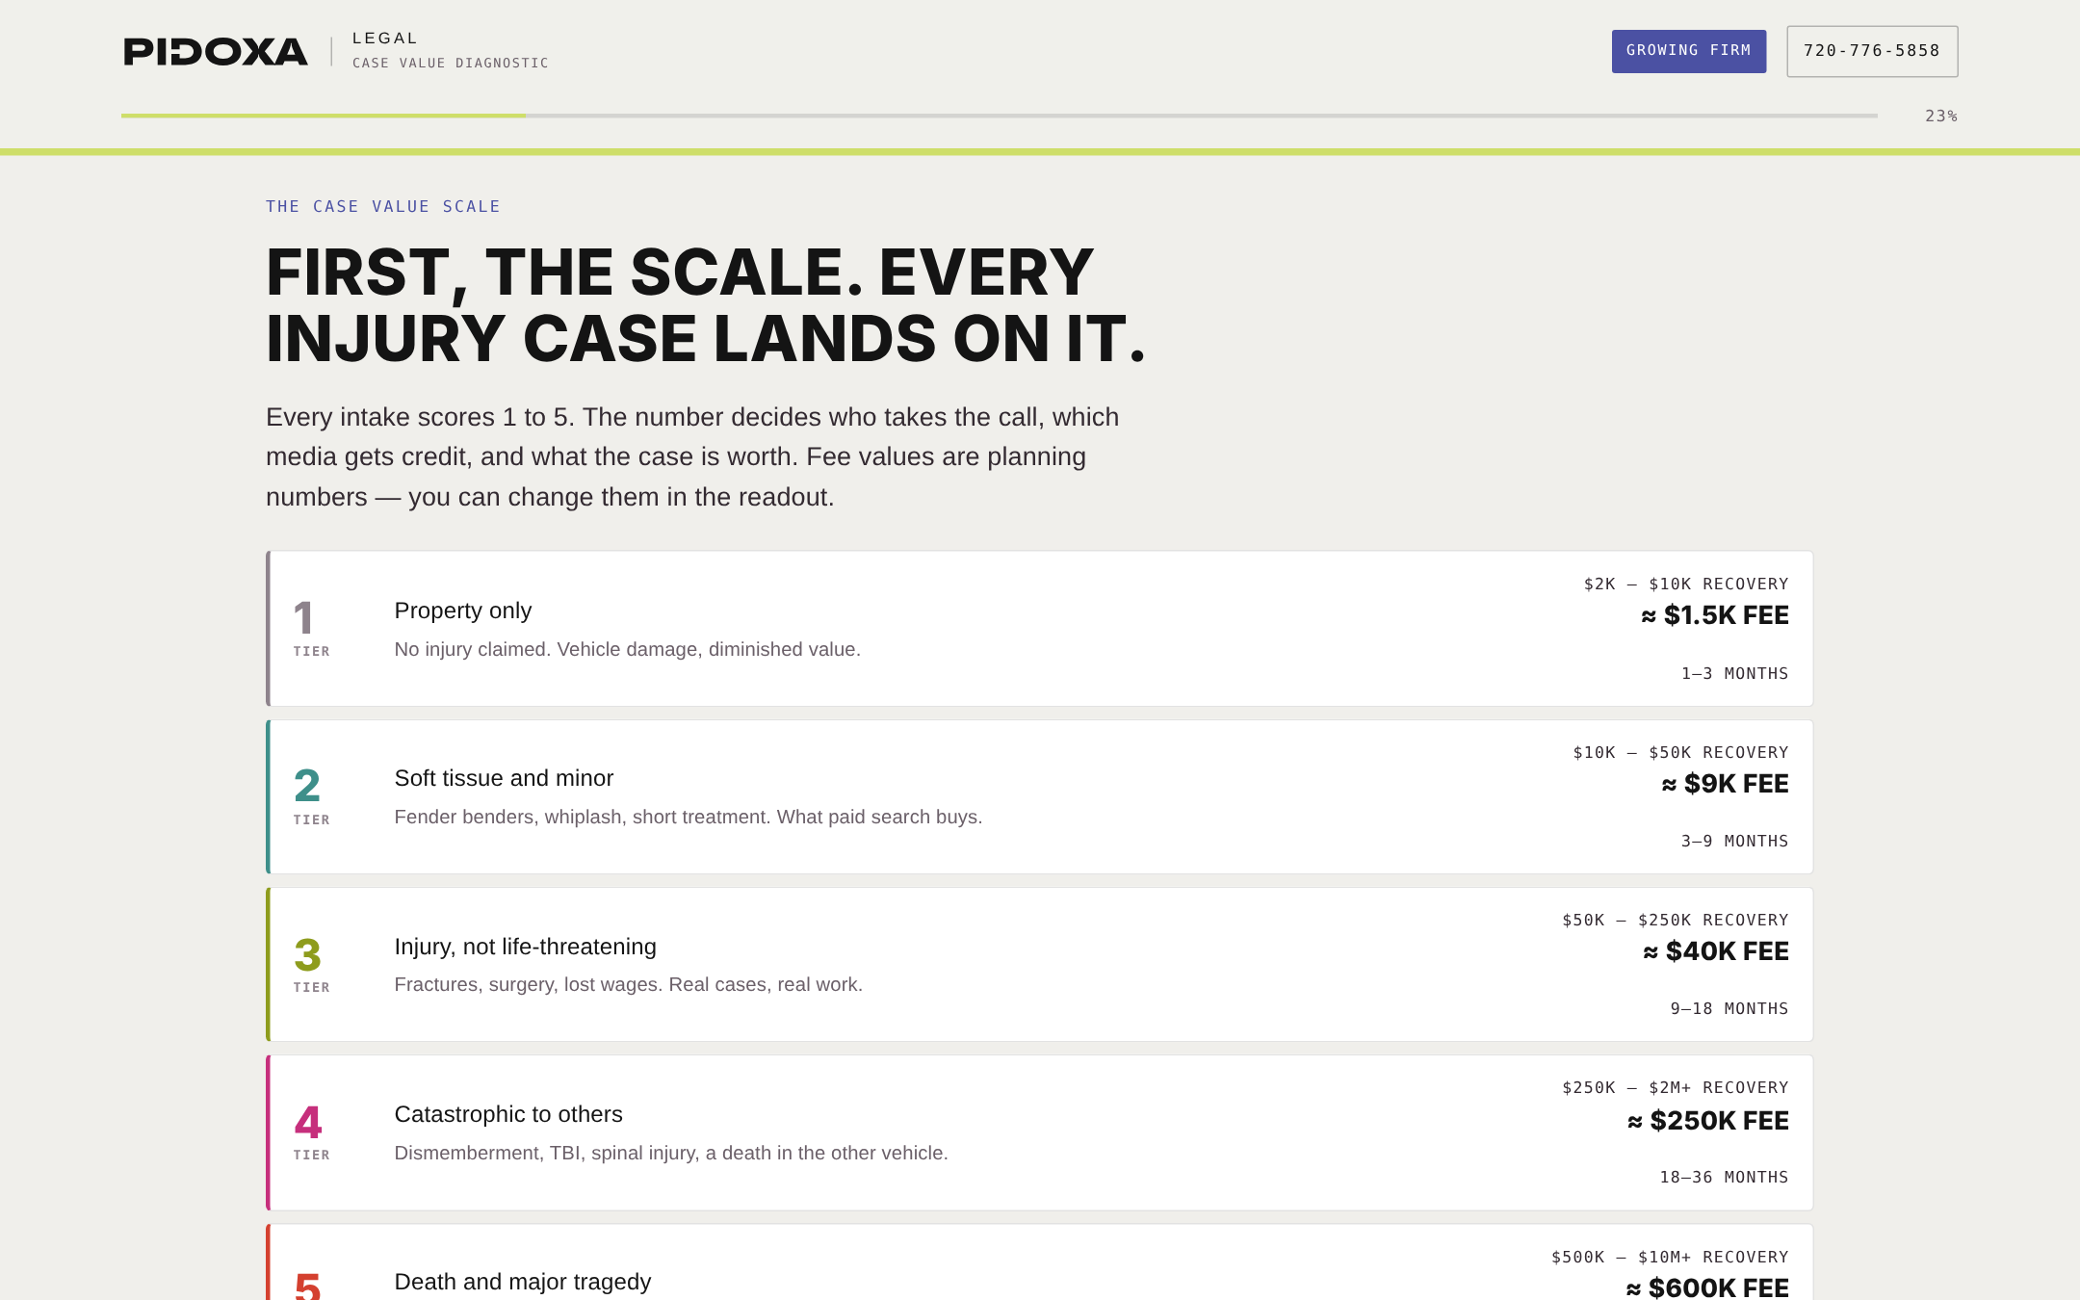
The scale step: tiers defined, then the attorney's last 100 signed cases distributed with five sliders that must add to 100.

4. Segmentation: firm size and footprint
Attorney headcount sets the provisional segment: 1–3 boutique, 4–10 growing, 11–30 established, 30+ or several offices regional. Spend over $250K a month moves a firm to established; $75K–$250K moves a boutique to growing; a multi-state footprint moves a boutique or growing firm to established, because multi-state media behaves like an established account whatever the headcount. The segment decides the program, the planning range, the default signed-case volume in the model, the ninety-day plan and the person the readout is routed to. Footprint decides whether connected TV and programmatic are introduced as a flight or as the backbone. The absence of any high-value case type (trucking, wrongful death, med-mal, product) adds an Expand gap and a finding.
Segment | Program | Program / mo | Media on top | Default cases / mo | Routed to
Boutique · 1–3 | Foundation | $6K – $12K | $5K – $20K | 6 | Growth Strategist
Growing · 4–10 | Full-Journey Growth | $12K – $30K | $20K – $75K | 15 | Senior Strategist
Established · 11–30 | Market Leadership | $30K – $70K | $75K – $250K | 40 | Joe Oltmann, CRO
Regional · 30+ | Partnership | $70K – $150K | Seven figures / yr | 120 | Joe Oltmann, CRO

5. The psychological triggers, and where each one sits
Two audiences, two sets of triggers. The first set works on the attorney moving through the diagnostic. The second set is the one the program is built to exploit on the attorney's behalf — the way an injured family actually chooses a firm. The deck describes both; the journey uses the first and teaches the second.

5.1 On the attorney, inside the diagnostic
Trigger | Where | How it is used
Reciprocity | Whole structure | The full readout — score, model, findings, plan — is given before any contact field appears. The ask arrives as "tell us where it goes," not "fill this in to see your results."
Self-selection and autonomy | Front door | The attorney names the symptom in their own words. Every later recommendation inherits that framing, so it feels like their diagnosis, not ours.
Personalization | Header tag, firm card, calc screen | "Growing firm" appears in the header from the second answer; the calc screen names the footprint and the mix shares; the readout opens with their firm described back to them.
Endowment | The scale sliders, the model controls | They distribute their own 100 cases and move their own volume and fee assumptions. The model's output is built on numbers they supplied, which is why the partners will not argue with it.
Loss aversion | "The one you lost," Lesson 2, findings, symptom table | The journey keeps the 4s and 5s the firm did not get in view. "Referral fees paid out" is loss made visible on the firm's own books.
Availability heuristic, made explicit | "Who did?" | Asking who got the last big case forces the attorney to notice that the family called the name they remembered — the whole brand argument in one question.
Contrast | Lesson 1, the method section | Click funnel beside client journey, with "you, today" on their side. The funnel is not disparaged; it is placed where it belongs — the 2s.
Authority | Notes under questions, fact strips, badges | Published benchmarks appear next to the question they are relevant to, with the source in a tooltip; Trade Desk reach and QuiqList recapture appear as facts, not a logo wall.
Social proof and similarity | Proof ranked by segment and answers; testimonial | The modeled PI illustration ranks first when the symptom is mix or brand; the ~1%-of-clicks study when the symptom is cost or media was paused; the "beat 94% of the market" story when the TV firm got the last 5.
Insight ("cheapest fix on the list") | Intake notes, findings | Intake is positioned as the thing that pays this month with no media spend. It lowers the perceived cost of saying yes and sequences the plan.
Labor illusion | Calc screen | Seven visible steps over ~3.5 seconds. The readout is perceived as built for them, not pulled from a template.
Anchoring | Fee values, planning ranges, "what one tier-4 case covers" | The fee per tier anchors the value of a case before the program's price appears; the range card then does the partners' arithmetic for them.
Commitment and consistency | Order of questions; summary on capture | Nineteen honest answers precede the commitment questions; the capture screen plays their answers back as "attached to your readout."
Consensus | Deciders → share-with | The readout can go to the partner or the administrator at the same time, "no sales call attached," so the second decision-maker is reached without the attorney having to sell internally.
Scarcity and urgency, kept honest | Timeline note, capture disclaimer | One injury firm per metro is a real conflict policy and a real scarcity; the Q1-2027 timing is true. Nothing is invented to create pressure.
Peak-end | Done screen | Named reviewer, repeated time, three concrete expectations, and the work to look at while they wait.

5.2 On the injured family — what the program is built to exploit for the firm
Trigger | Where in the family's journey | What Pidoxa builds for it
Availability and recognition | Before the crash; search and ask | Connected TV and streaming in the metro, the attorney on video, community presence — so the name is already in memory when it is needed. Signal and Create.
Social proof | Search and ask | Review count and rating (53% exclude under four stars), case stories, named results with disclaimers. Create.
Authority and competence signals | Search; first contact | Results pages, press, the attorney explaining what happens next in plain language; intake that sounds like it has heard a tier 5 before. Create and Acquire.
Ambiguity aversion and cognitive load | The first 72 hours | A "what to do now" path for the family member, no jargon, one clear next step, click-to-call and chat. Acquire.
Responsiveness as a proxy for care | First contact | Five-minute live response 24/7 — 79% hire the most responsive firm, and 72% abandon after 24 hours. Acquire.
Reciprocity and commitment | Decide and sign | Help given before the retainer (guides, the plain-language fee explanation), e-sign from the bedside, a named attorney and case manager in the first message. Acquire.
Consistency and closure | Treatment; resolution | A communication cadence, the review asked at close, the story told with consent — the result earns the next case. Lift and Create.

6. Symptoms of a brand and earned-content gap — as the journey argues them
The journey's central argument is that most of what injury firms treat as media problems are brand problems. Lesson 2 lists the symptoms; the readout's symptom table maps each to a root cause and a SCALE letter and marks the rows the attorney's own answers point at. The full table is section 5 of the case-study paper. The argument runs: a catastrophic case is remembered before it is researched; if nothing is there when the family searches the name, the paid impression was wasted; if something is there, every paid dollar works harder; therefore memory media is measured by branded search and direct traffic, not last clicks, and earned content is the thing the media plan is paying to be confirmed by.

7. The client journey — the family's path, the friction, what we remove
This is the journey the program is designed to, written for the injured person and the family together. Each stage has a friction point where the 5 is lost and a SCALE capability that removes it; the readout marks the stages where the attorney's answers say the friction is today. The eight stages — before the crash, the first 72 hours, search and ask, first contact, decide and sign, treatment and the case, resolution, referral and return — are set out in full in section 6 of the case-study paper and rendered in the readout as the map below.
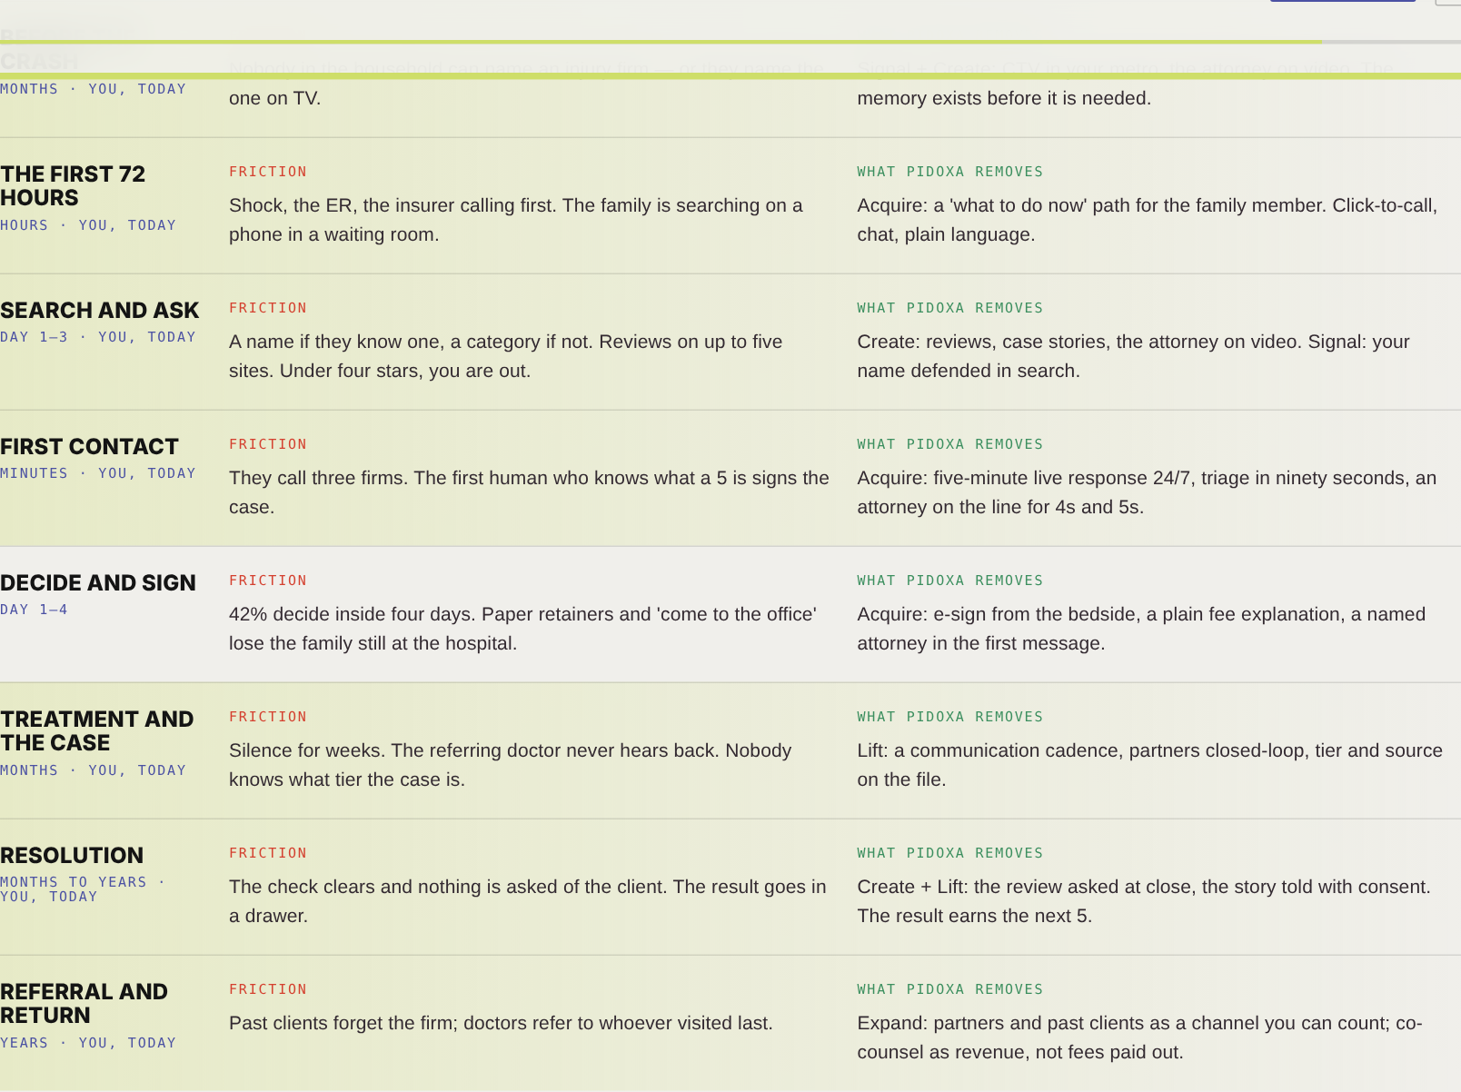

8. How the SCALE engine is explained
The brief asked the journey to explain what Pidoxa does using the same SCALE acronym as the Fiber Velocity engine. It does so in four layers, never as a vendor list:
- Notes under questions carry one capability fact each, where it is relevant — 98% reach under footprint; the parallel buy flow under the family-member question; 51% live-chat under the website question.
- The five pillars of the score are the five letters, so the attorney has read S·C·A·L·E as their own scorecard before the engine is named.
- Findings each end with the letter and the capability that closes them, so the engine is introduced as the answer to a problem the attorney just admitted to.
- The engine section lists the five letters with their legal-specific definitions and marks "named in your findings"; the program lists the services under each letter, ordered by the symptom they picked, with intake pulled into the first three whenever it is broken.
Letter | Fiber Velocity definition | Legal definition (this journey)
S · Signal | Digital and media marketing | CTV, streaming audio, programmatic and OOH build the memory in the metro; search and LSAs harvest the moment; retargeting and QuiqList catch what leaks; every channel reports into one cost per signed case, by tier
C · Create | Content for earned media and brand | Case results as stories with required disclaimers, attorney video, community and press, a reviews program — the content that makes the family say the name first
A · Acquire | Lead gen, nurture and the parallel buy flow | Five-minute response 24/7, tier triage, e-sign from the bedside, nurture for the not-yet-ready, the parallel flow for the family member, the referral partner flow
L · Lift | Brand equity strategy, events, earned media, NPS playbook — the strategic plan | Brand lift measured weekly, tier attribution, the NPS and referral playbook, events and earned media, one scoreboard the partners read the same way
E · Expand | "Wreck-it Ralph": new areas, new sales channels, new legs of revenue | Trucking, premises, product and med-mal lines; the next metro; a co-counsel network that pays the firm; the Spanish-language market; mass tort when it fits

9. The case-mix model, scoring and findings

9.1 The model
Inputs: the mix from the scale step (default 20 / 45 / 25 / 8 / 2); signed cases per month by segment (6 / 15 / 40 / 120, slider 2–400); the planned shift of −10 / −12 / +8 / +10 / +4 points applied 0–150%, clamped at zero and renormalized to 100; and tier-4 and tier-5 planning fees (default $250K and $600K). Outputs: expected fee per signed case today and shifted; modeled annual fees today and shifted with the delta; a per-tier table; and lead value by channel (average sign rate × expected fee) beside published cost per lead and cost per signed case. Worked default for a growing firm: $46,350 → $97,320 per signed case; $8.3M → $17.5M a year; tiers 4–5 from 10% to 24% of signed cases. The readout labels it a planning illustration, not a projection.

9.2 Scoring and bands
Every answer option carries a gap score from 0 (healthy) to 3 (critical) toward one SCALE pillar. Pillar percentage = 100 × (1 − gap ÷ max gap). Three computed gaps are added: Signal gets a channel-mix gap (breadth, plus one point if no memory channel is running, plus one if a shared-lead vendor is); Expand gets two points if no high-value line is signed; Create gets 0–3 points from the mix itself (tiers 1–2 at 40 / 55 / 70%+). The readiness score is the weighted sum — S .20, C .22, A .24, L .20, E .14 — clamped 8–98.
Band | Score | Word | Headline
High | 70+ | BUILT TO SCALE | Your firm is earning the cases it signs. The question is how many more 4s and 5s the metro has for you.
Mid | 42–69 | MIX STUCK IN THE 2s | Your firm is buying the small cases and losing the big ones to a name the family already knew.
Low | under 42 | LEAKING THE 5s | Your firm is spending without a scoreboard, and the cases that define a firm are going elsewhere.
Findings are rules over the answers: up to seven, sorted by severity, each with a title in the attorney's situation, a body that explains the mechanism, and a fix that names the SCALE letter and capability. Intake findings sort first at equal severity because intake pays first. Proof is ranked by segment fit and by the answers that make each story relevant.
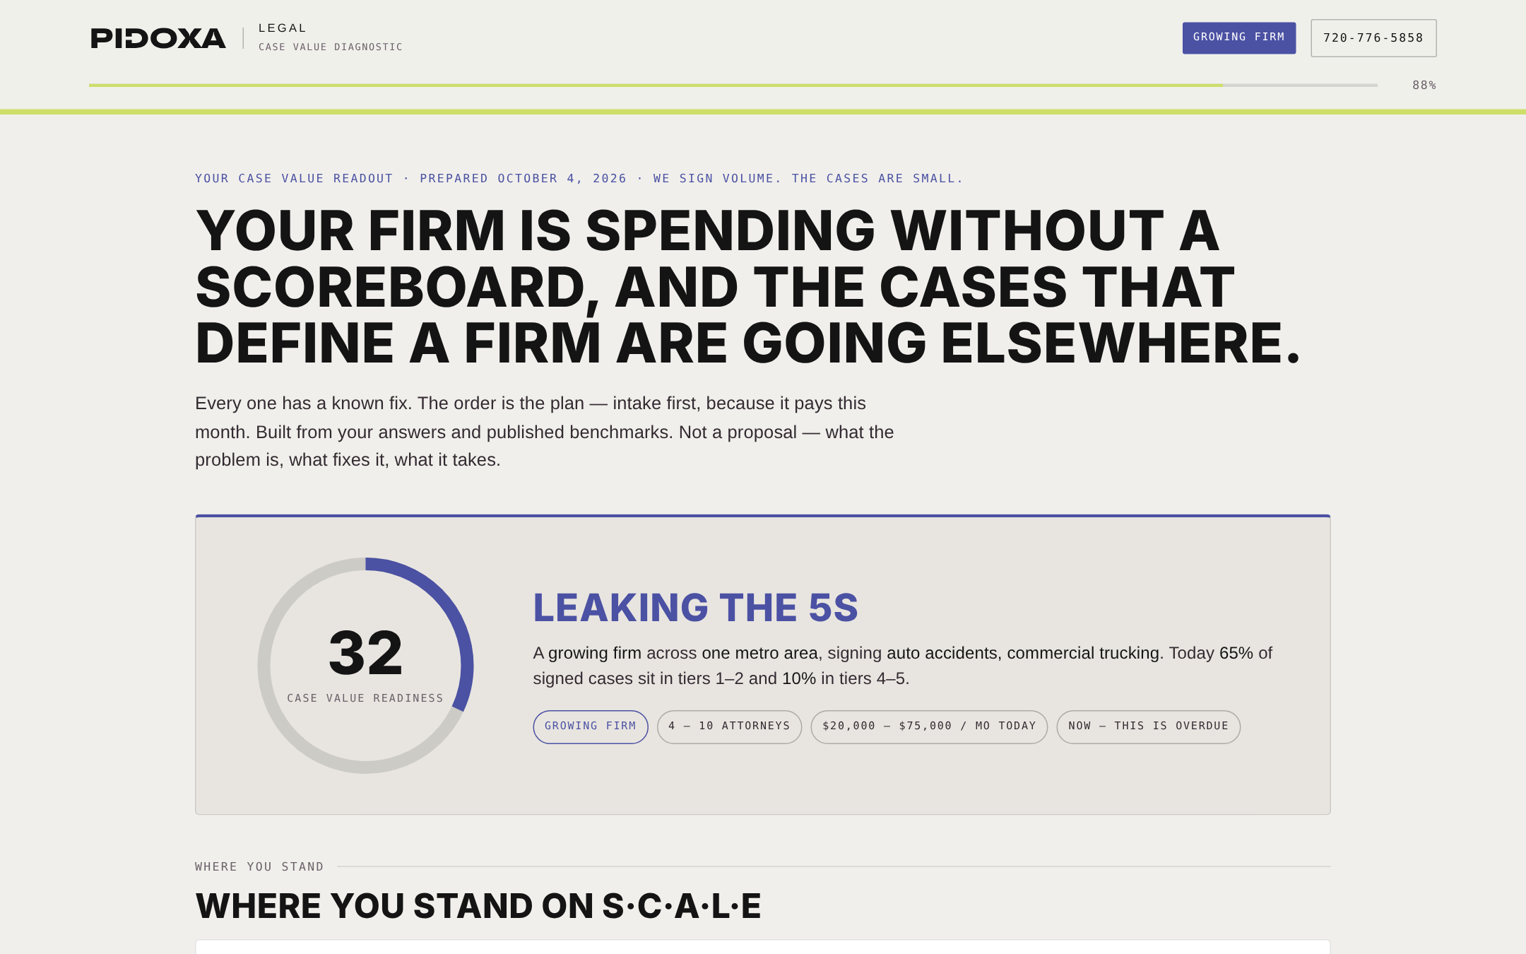
The readout: headline by band, readiness gauge, firm card with the mix shares.

10. Compliance

10.1 What the program promises the firm
- ABA Model Rule 7.1 — nothing false or misleading; no outcome guarantees; "prior results do not guarantee a similar outcome" on every published result; hedged language rather than promises.
- Rule 7.2 — no paying for recommendations outside ordinary advertising cost and qualified referral services; "specialist" only with an accredited certifying body named; a responsible attorney or firm identified on every piece.
- Rule 7.3 — no live in-person, telephone or real-time electronic solicitation of accident victims; state waiting periods on written solicitation and "Advertising Material" labeling respected; stop on request.
- State overlays (California B&P §6157.2 and similar) — no quick-cash framing, dramatizations disclosed. Bar counsel reviews creative before it ships.
- Client stories and results only with written consent; HIPAA-sensitive detail excluded; TCPA consent on every intake form the firm runs; CCPA/CPRA notice and Do-Not-Sell link for QuiqList.

10.2 The journey's own capture
- TCPA-compliant consent checkbox naming Pidoxa, automated technology, SMS, "not a condition of purchase," STOP/HELP, with Privacy and Terms links; consent text and timestamp travel in the payload.
- Reciprocity means no field is required to see the readout; the capture asks only what intake needs.
- One-firm-per-metro conflict check stated at capture and on the done screen.
- Footer disclaimer: planning figures are benchmarks and modeled illustrations, not projections; advertising rules vary by state; nothing is legal advice.

11. Data, CRM and analytics
Submission posts to the Pidoxa HubSpot portal (246470475) through the "Pidoxa Contact Us" form — the same form the CMS pages and the Marketing Growth Plan use — with business_unit = marketing, funnel_key = pidoxa-legal-pi-case-value, funnel_score and funnel_level, and the entire readout written into the message field so sales reads it on the contact record: mix, model inputs and outputs, every answer, requested time, share-with and notes. Set CONFIG.leadEndpoint to route to a server proxy or the CMS leads API instead; buildPayload() documents the JSON shape. GTM container GTM-5WSBGCSC receives pdxl_* events: journey_start, step_complete (step, key, value), learn_complete, readout_building, readout_generated (score, band, program, low share), cta_click, readout_print, lead_captured, lead_submit, lead_success, lead_error.

12. Mounting and the pre-launch checklist
Mounted on HMS under the Joe Oltmann client, dev agent, plain image, at pidoxa-legal.hosting.pinbn.net, as a single self-contained index.html with the rationale page (journey.html) beside it and the deck and papers under /docs/. Hash routing means no server configuration; the page is noindex until the practice group decides otherwise. Typekit (TT Travels Next, Futura PT) and Google Fonts (Space Mono) load from the same kit the Pidoxa CMS marketing module uses, so the brand renders exactly as pidoxa.com/marketing does.
- Confirm the planning ranges and the one-firm-per-metro policy with Frank before the first attorney sees them.
- Decide whether bookingUrl should carry a HubSpot Meetings link for the strategists and for Joe; otherwise the day/window picker stands.
- Replace the default fee values with the first client's closed-case file in week one of every engagement; the journey's defaults are industry benchmarks.
- Add a legal practice-group page at pidoxa.com/marketing when it exists and point the brand link at it.
- Submit a boutique, a growing and an established readout end to end and confirm the HubSpot record reads cleanly and the routing name matches.
- Have bar counsel in the first target state read the lesson copy and the readout's compliance note.

